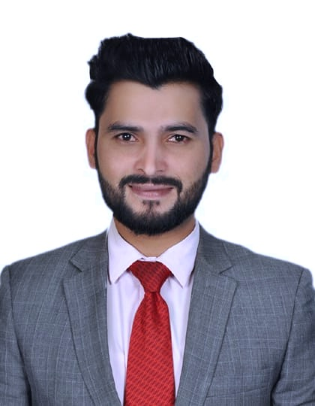
TAHIR SALEEM
Sales Business Development | Digital Marketing Plans & Execution | Lead Generation | Solid in B2B & B2C

tahirsaleemdxb@gmail.com https://www.linkedin.com/in/tahirsaleemdxb Dubai, UAE

Visa Status: Visit Visa, Availability: Immediately, Driving License: Available UAE

PROFESSIONAL SUMMARY
Enthusiastic and knowledgeable Sales Business Development Manager with over 6-years of experience, specializing in up-selling auto Insurance, Building Material, Interior design, and Fit-out Industry. Skilled in sales operations, business growth, Strengthening Company’s market position, Maximizing the business performance, and relationship building in a productive way. Regularly looking for ways to increase sales and capture the maximum market share by using different social media & marketing techniques. Won B2B & B2C Sales Excellence Award twice, with a proven record of growing business market by over 100% in 6 months. In-depth knowledge of the UAE business market.

ACCOMPLISHMENTS
- Organized the company’s annual international Exhibition held in Expo center Dubai and independently generated over 01 Million in 3 Days.
- Revamped business pages on different digital social media platforms that have led to 65,000 followers (up by 40% in 3 months), and have led to 4% increase in revenue.
- Successfully negotiated 12% discount on all products and services resulting in total savings of 26,000 per month.
- Grew working capital by 30% in 6 months, with direct sales, cold calling, personal visits, and meetings that allowed the company to take advantage of better resources for continued growth.
- Negotiated the largest contract with the new business partner to date, 2-years exclusivity agreement worth 1.5 million.

EXPERIENCE

Continental Car Hire Limited | Sales Business Development Manager
- Designing, implementing a strategic sales plan that expands company’s customer base in order to achieve targets within the given time frame.
- Recruiting and managing staff, building client relationships, balancing stakeholders, detecting new business opportunities, and negotiating and closing deals.
- Built and maintained relationships with potential clients and business partners in order to get access to new opportunities.
Key Achievement:
- Achieved monthly, quarterly and yearly sales margins and goals - Average Sales 90% for 2020 - 202021
- Closed at least £2.5 million in recoveries sales each year.
- Received at least 25 customers referrals, which brought in over £50,000 in new business.
_______________________________________________________________

Balqis Building Materials Trading LLC | Business development & Sales Executive

- Research and identify new business opportunities including new markets, growth areas, trends- or new ways of reaching existing markets.
- Do sales promotion B2B & B2C through personal meetings and visits.
- Do a minimum of 50 productive meetings with potential clients per month.
Key Achievement:
- Exceeding monthly sales quotation from 31%-46% through personal visits and cold calling.
- Developed 2.5 million of new business potential with international and domestic customers through honest and deliberate relationship building.
- Brought in 250 potential clients by learning client’s needs and offering solutions.
_______________________________________________________________

Stones Building Materials Trading LLC| Assistant Sales & Marketing Manager
- Visiting under-construction villas and projects on a regular basis as per a pre-planned schedule.
- Present, promote, and sell products & services to prospective customers with solid griped on product knowledge.
- Provide market updates, information, and new trends to BDM to capture the maximum market share and beat the competitors.
Key Achievement:
- Achieved 70% sales growth annually.
- Prospected potential new clients and turned them into increased avenues of business and have led to a 05% increase in overall sales.
______________________________________________________________

Black Arrow Communication Services | Business Development and Sales manager
- Support CROs on incoming calls with difficult customers or calls that require in-depth knowledge of the company's products or services.
- Monitoring and evaluating agent performance, providing learning and coaching opportunities, and taking corrective action.
Key Achievement:
- Designed and implemented strategic business plans that increased revenue by £890k per year.
- Developed negotiating strategies that have led 31% increase.

EDUCATION
BBA (Hons.)
Major in Sales & Marketing
University of Education Lahore
2011 – 2015 Lahore, Pakistan

ABILITY & COMPETENCIES
- Negotiating with the customers and business partners to increase purchase values.
- Leading a team of 06 to generate a target pipeline of leads over 2 months with regular check-ins, progress updates, and supporting under-performers.
- Reputation for being patient, business relationship, close deals, a resourceful problem solver, and directed the implementation of an email integrated voice mail system that helped increase revenue by 11%
- Social Media & Digital Marketing | Sales pitch development | Sales Presentation & Organizational skills Public Speaking | Interpersonal Skills | Adaptability & Conflict Management

ACHIEVEMENTS

- Added 875k revenue from the total sales of 3.5 million at Stone building materials
- Added 300k revenue from the total sale of 1.5 million at BBM in less than 10 months
- Acquired 50 new sales accounts within a month and brought 3.66 million through visits
- Lead a Team and Added 100k Within 15 Days
- Added 250k in a Month of September 2021
- Added 100k within Two Months

AWARDS
- Best Employee of the year Dece2017
- Two times recipient of the B2B Sales Award for Excellence.
- Best Product line presenter at Exhibition held in Expo Center Dubai 2019.

AREA OF EXPERTISE
- Product Development
- How to get the Maximize market share
- How to increase revenue in terms of business expansion
- How to increase profitability by building strategic partnerships and making strategic business decisions.
- Aware of new market opportunities, possibilities for expansion, competitor’s development, and cost-saving efforts.

PUBLICATIONS
- Tahir Saleem, Nida Tanveer, and Zubair Azam (2015). “Service Quality, Customer Attitude and Subscription Behavior”
- Tahir Saleem, Saif Ullah and Rida Saleem (2015) “The Impact of Advertising and
LANGUAGES
Language: Mother Tongue Urdu & Punjabi. Fluent in English and fully working knowledge Hindi and Arabic.
Sales Promotion in Revenue”

RESEARCH SEMINARS

- Presented final Year project at second International Conference held by University of Education Lahore 2015.
- Participated in “HOW TO DEAL INTERNATIONAL BUSINESS RELATIONS” in the first National conference held by Punjab University Lahore 2015.
- Presented a case study “ HOW ORGANIZATIONAL CULTURE IMPACT ON EMPLOYEES PERFORMANCE” at the University of Education held by under 12 Campuses 2013.
- Participated in the Annual Nat competition held by University of Education Lahore 2013.

Certification of Attendance
- Role of the Leader in Talent Development.
- How self-Motivation impacts your career.
- What are the key factors that have to keep in mind while presenting the company’s goods and services.
- How product knowledge is necessary before visiting the target market.
- Why cannot ignore Direct sales strategy and not only focus on digital marketing
- Driving License Dubai, UAE 2018.

- English —Communicative
- Hindi —Communicative
- Urdu —Mother Tongue
- Punjabi —Mother Tongue
- Arabic —Beginner

