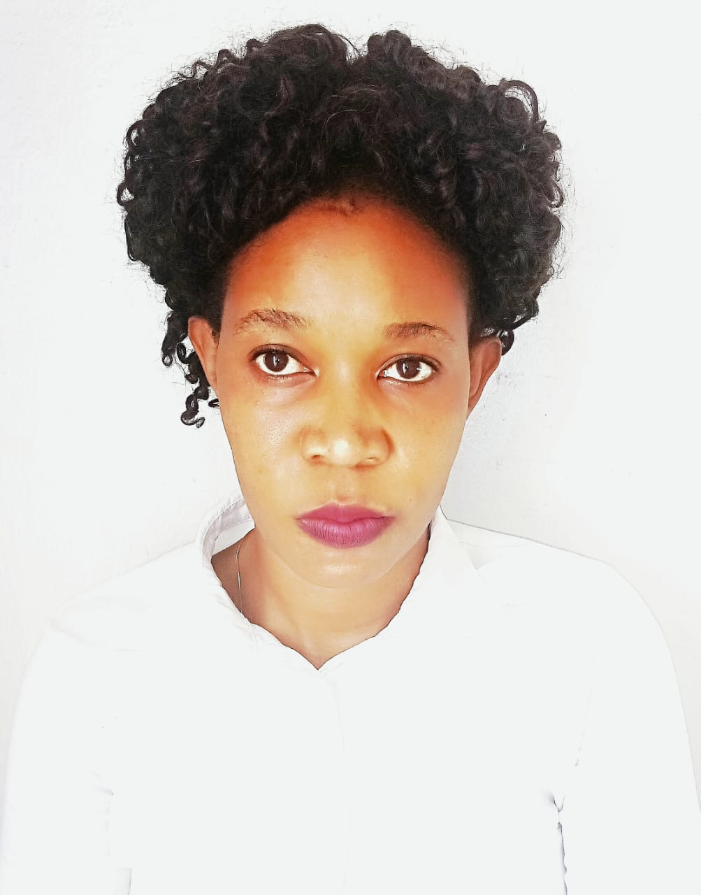
RACHEAL BIRUNGI
DUBAI, UAE. Discovery Gardens. 0582601027. rachealb588@gmail.com
Visa Status – VISIT VISA
BARISTA
A professional, dedicated and organized BARISTA with enough experience driving customer service, preparing and delivering beverages within a first paced food service environment
Key skills
- Knowledge about coffee roasting process and growing methods  - Latte, Cappuccino, Macchiato, Americano, Flat white, Espresso, mojitos, Oreos, Pistachios, milkshakes, skills  - Juice making | - Great Hospitality  - Quick learner  - Verbal and written communication in English  - Espresso pulling, coffee brewing and Latte art  - Multi-tasking and effective time management  - Food and Drink prep handling  - Operating POS systems and Cash handling
PROFESSIONAL EXPERIENCE
LANDMARK (Max’s All about Chicken Restaurant)
Waitress/Barista (June 2021 up to July 2023)
Tasks;-
- Welcomed our guests at all times with exceptional customer care
- Prepared and served hot and cold drinks such as coffee, tea, and artisan and specialty beverages.
- Cleaned and sanitized work areas, utensils and equipment.
- Cleaned service and seating areas for a conducive and welcoming place
- Described menu items and suggested products to customers.
- Serviced customers and punched orders
- Prepared and served Hot and cold beverages like, Espresso, Latte, Cappuccino, Macchiato, Flat white, Americano among others

COFFE AT LAST Kampala Uganda
BARISTA (2018-2020)
- Took orders, served Hot & Cold Beverages, set and cleared tables, and dealt with the exchange regulations
- Prepared different kinds of juices
- Ensured all tables received their drinks and food as requested
- Maintained the cleanliness of all equipment used during shifts
- Maintained cleanliness and stores to Health, Safety and Hygiene standards at all times
- Showed complete awareness of all the drink and food menus and readiness to explain and recommend food and drink contents
- Complied with Company Health and Safety, and Fire Regulations and procedures
- Maximized revenue and increase average spend per person through upselling, high customer service standards, effective training and motivational techniques.
- Demonstrated a perfect knowledge of all beverages served, how beverages are prepared (to recipe) and presented to junior colleagues
- Mate or exceeded the monthly drink profit margin target
EDUCATION & CREDENTIALS
MAKERERE UNIVERSITY, Kampala Uganda.
Bachelor’s Degree (Hotels & Institutional Catering)

Summarized experiences
- LANDMARK (All About Chicken Restaurant June 2021 up to July 2023)
- Coffee at Last (2018-2020)

Notice : Readily available and I can join immediately

REFEREES
Available upon request

