ADNAN KHAN

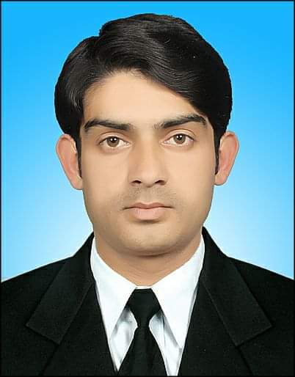

**EDUCATION**

**CONTACT**



**MA English (Literature and Linguistics) 2015-2017**

University of Swat

**BA English (Elective English) 2012 - 2014**

Abdul Wali Khan University, Mardan

**Higher Secondary School (Grade 12) 2010 - 2012**

Mukhtar College of Commerce, Islamabad

**Secondary School Certificate (Grade 10) 2009**

Govt High School Qambar, Swat

+971-581146962

adnangombak006@gmail.com



City Sharja area, BMW road,

Al Khyal building, UAE

**PROFILE**

* Strong verbal, written and interpersonal communication.
* Courteous, patient, respectful, loyal, discreet, trustworthy, innovative team player, able to develop easy rapport with others while building trust.
* Able to work within group or independently.

**WORK EXPERIENCE**

**SKILLS**

**Elementary School English Teacher**

**The Asian School & college, swat Sept, 2021- Feb, 2022**

***Duties***

* + **Teach at O & A Levels**
  + **English Text**
  + **English Drama & Poetry**
  + **Grammar (Basic/ Advance)**
  + **Functional English**

**ESL Teacher**

**Blossom English Coaching Academy (Part time job) March, 2021- Dec, 2021**

***Duties***

* + **Teaching English as a second Language**
  + **Teaching Advance Grammar**
  + **Teaching technical writing.**

**Front Desk Receptionist/ Agent (part time) 2015 - 2017**

**Aftab Dental Hospital, swat Pakistan**

***Duties***

* **Dealing with patients**
* **Handling complaints**
* **Making appointments**
* **Exchanging emails**
* Microsoft Office
* Creative Thinking
* Organized & Detail-oriented
* Strong Written & Verbal Communication

**REFERENCES**

**Mr. Imran** Head of the English academy, swat.

Email: [imrankks900@gmail.com](mailto:imrankks900@gmail.com)

Cell : +923345095649

**Mr. Haider Ali,** Principal of

The Asian School and College, swat.

Email: [director@asian.edu.pk](mailto:director@asian.edu.pk)

Cell: +923003526222

+923423526222

**Mr. Saifullah Khan,** Lecturer at

Department of English, Govt PG Jahanzeb College, Swat

Email: [saif.gjc1@gmail.com](mailto:saif.gjc1@gmail.com)

Cell: +923479043319

**LANGUAGES**

English

Pashto

Urdu